The Battle of the Neighbourhoods (New York)

# Table of contents

* Introduction: Business Problem

• Data

• Methodology

• Analysis

* Analyse Each Borough

• Results and Discussion

• Conclusion

# Introduction: Business Problem

In this Capstone project I am trying to figure out the most popular venue in New York City and to find out the optimal location/neighbourhood that is not already crowded with that popular venue. I am also trying to analyse the venue in each Borough in New York City. Specifically, this report will be targeted to stakeholders interested in looking most popular venue in New York City and to find appropriate location that is not already crowded.

Since there are lots of variety of venues in New York, we will try to detect **most popular venue and location that are not already crowded with that venue**. We would also prefer locations **as close to city as possible that covers most nearby neighbourhoods**, assuming that first two conditions are met.

# Data

As per my problem description, below mentioned factors will influence my decision:

* Variety of venues in the neighbourhood.
* Number of different venue type in each Borough.
* Number of neighbourhoods in each Borough that is not already crowded with most popular venue.
* Location of each uncrowded neighbourhood to cluster them and find out highly dense cluster.

I will be using the following data sources to extract the required information:

* Raw data for New York City will be downloaded from external source.
* Borough, neighbourhood and their latitude and longitude data will be extracted from downloaded data.
* Number of venues, venue category and corresponding latitude and longitude of each venue in every neighbourhood will be obtained using **Foursquare API**.

So by using these information we will try to find out most common venue and optimal location for such venue. These neighbourhood data will be clustered by using ***K-mean Clustering*** method to identify optimal group of neighbourhoods which are not already crowded with most common venue.

Final data looks as mentioned below:

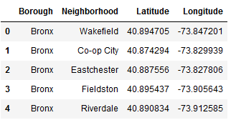

We examined that there are 5 borough and 306 neighbourhoods.

## Create a map of New York with each Borough & neighbourhoods

We create a map with each borough and corresponding neighbourhoods. To distinguish each borough and its neighbourhoods, we used different colour for each borough.

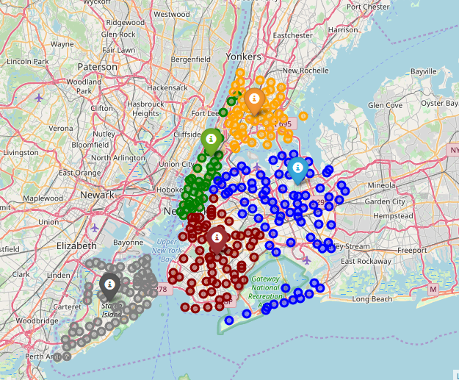

## Exploring neighbourhood by using Foursquare API

We explored each neighbourhood and find upto 100 venues in each neighbourhood and store them in a data frame. Final data looks like as below:

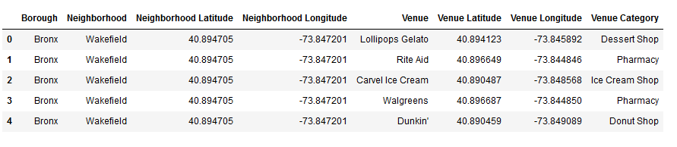

# Methodology

In this capstone project my main objective is to explore each borough and find out the **most popular venue** and then figure out the **optimal location** which is not crowded with that popular venue and cluster the neighbourhoods to identify highly dense cluster of neighbourhood which have not already crowded.

In first step I have collected the required data from external source and then explored each neighbourhood by using Foursquare API to find venues in each neighbourhood.

Second step in our analysis will be to find the top 5 most common venues in each borough.

In third and final step I will filter the original data with neighbourhoods which has no top most common venue. Then visualize each neighbourhood. My main focus is to find out most promising area/zone that meet some basic requirements established in discussion with stakeholders. I will prompt map of all such locations and also create clusters (using **k-means clustering**) of those locations to identify highly dense neighbourhoods which would be target for optimal venue location by stakeholders.

# Analysis

First we aggregate the each borough and number of different venues in each borough as below.

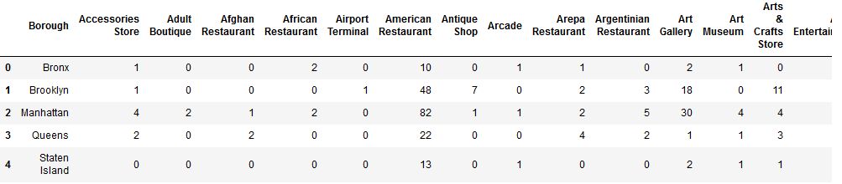

After that we aggregate the data by borough and neighbourhood combined and find the number of different venues in each borough and neighbourhood combinations.

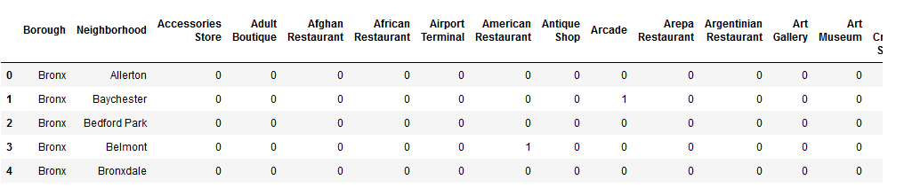

Then we examined the top 5 common venues in each borough.

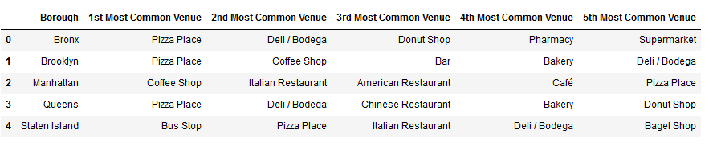

Here we find that each borough has pizza place as common venue. So we start analysing each borough and cluster them into non-pizza place neighbourhoods.

# Analyse Each Borough

## Cluster Analysis for Bronx

We found that there are 40 pizza places and 12 non pizza places in Bronx borough. So here is the cluster of each non-pizza places in Bronx borough.

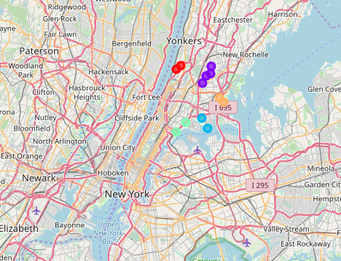

## Cluster Analysis for Brooklyn

In Brooklyn borough there are 54 pizza places and 16 non pizza places.

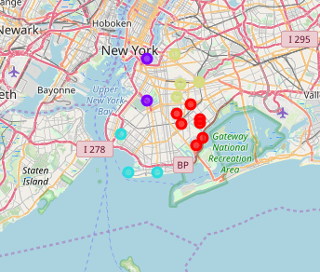

## Cluster Analysis for Manhattan

In Manhattan Borough there are 33 pizza places and 7 non pizza places.

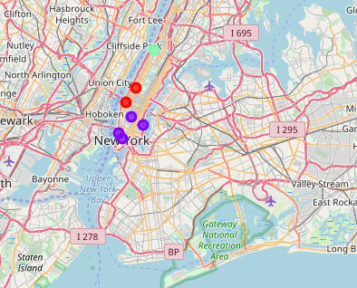

## Cluster Analysis for Queens

In queens borough there are 48 pizza places and 33 non pizza places.

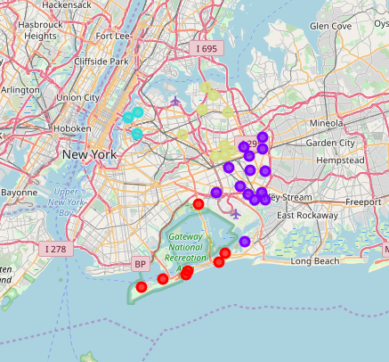

## Cluster Analysis for Staten Island

In Staten Island there are 29 pizza places and 33 non pizza places.

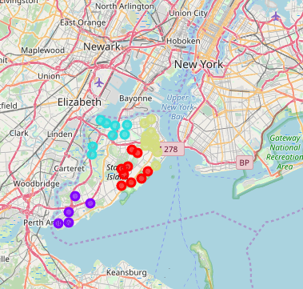

From the above visual representations we can see that **Queens and Staten Island** both are not much crowded with pizza place. In Queens' **cluster 1** consists majority of neighbourhoods so it can be considered for optimal location. Similarly in Staten Island we can see that all clusters are highly dense and **cluster 3** is more appropriate cluster to be considered for optimal location.

Let's see which cluster is optimal for consideration by adding neighbourhoods having pizza place in Queens and Staten Island.

## Queens Cluster with pizza places:

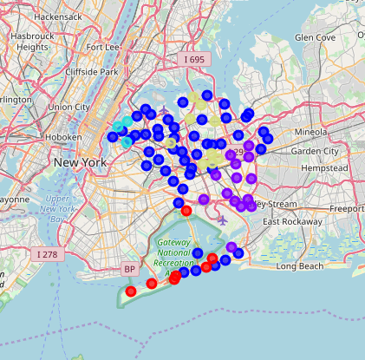

## Staten Island cluster with pizza places:

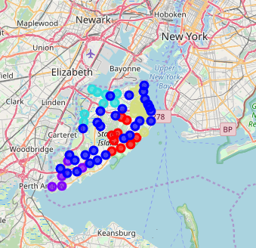

Here we added neighbourhood with pizza place and we can clearly see that in Staten Island all clusters are more closely surrounded by pizza place. While in Queens' cluster 1 is not as much crowded with pizza place. So we can select **Queens' cluster 1** for optimal location.

Now let's calculate the centre of this cluster which is the mean of latitude & longitude of each neighbourhoods separately and visualize the cluster along with centre.

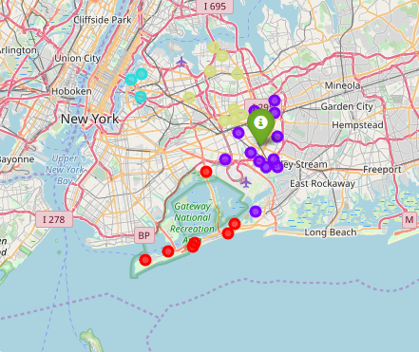

Next step is to sort the data frame based on distance in increasing order. So we get the first row as shortest distance neighbourhood.



Visualizing that optimal neighbourhood again:

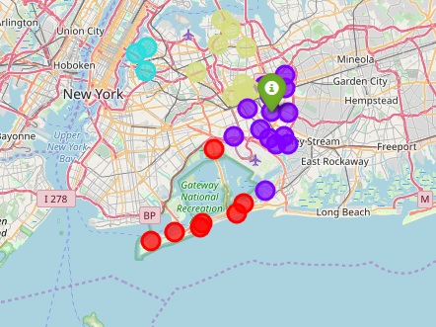

# Results and Discussion

As our analysis and graphical visualization shows that there are number of different venues in each borough. But we have seen that each borough has mostly crowded with pizza places. And in each borough there are neighbourhoods with pizza place and non-pizza place. Their ratio are mostly fair in each borough but geological location is different. In some borough non pizza places are surrounded with pizza places and in some borough they are isolated. So our attention was focused on such areas which are isolated from pizza places and covers major neighbourhood of non-pizza places.

Focusing on the objective we first group the data by borough and find out the number of occurrence of each venue type. And then sort the venue type by its number of occurrence which shows the top most common venue which is pizza place.

We again sort the data by borough & neighbourhood combined to see that which neighbourhood has top most venue in each borough. We filter these neighbourhood which has no pizza place.

These location were then clustered to create zones of interest which contain large number of neighbourhood not already crowded with pizza place.

Result of all this shows that there are two clusters which can be considered for optimal location for pizza place. One cluster is from Queens’s borough and other is from Staten Island. Both clusters fairly contains large number of neighbourhoods. But in Staten Island cluster is already surrounded by pizza places which are more close to non-pizza places. While in Queens' cluster pizza places are far as compared to Staten Island. So we are considering Queens' cluster to find optimal location. For optimal location we first calculate the centre of that cluster and then calculate the distance of each neighbourhood in that cluster from centre. We sort the distance to find the closest location from centre which was **St. Albans** in **Queens borough**. This recommended location should therefore be considered only as a starting point. There may be other factors taken into account and other conditions may be introduced for optimal location.

# Conclusion

Purpose of this capstone project was to identify an optimal location that is not crowded by most common venue in New York City. It gives stakeholders as a starting point for consideration. We calculated the number of occurrence of each venues in each borough which gives an idea about most common or popular venue in each borough. We found that pizza place is most common among all borough. Then clustering of those neighbourhoods where there were no pizza place gave us a zone of interest that meet some basic conditions.

We considered the cluster of neighbourhoods which was not already crowded/surrounded by pizza places.

Final decision on optimal location will be made by stakeholders based on specific characteristics of neighbourhoods and locations in every recommended cluster of neighbourhood, taking other factors and conditions into consideration.

.